URL: https://adityabirlahospital.com/doctors/vascular-surgeon-in-pune
Meta Title: Best Vascular Surgeons In Pimpri-Chinchwad, Pune | ABMH
Meta Description: Find the best vascular surgeons in Pimpri, Pune at ABMH. Expert care and advanced treatment for all vascular conditions. Book an appointment now!
Home / Doctors / Vascular Surgeon
Best Vascular Surgeons in Pimpri-Chinchwad Pune
When vascular health requires attention, choosing experienced specialists is crucial. At our hospital, you’ll find leading vascular surgeons in Pune who provide advanced care for conditions affecting arteries, veins, and the lymphatic system.
Our Team of the Top Dentists in Pune
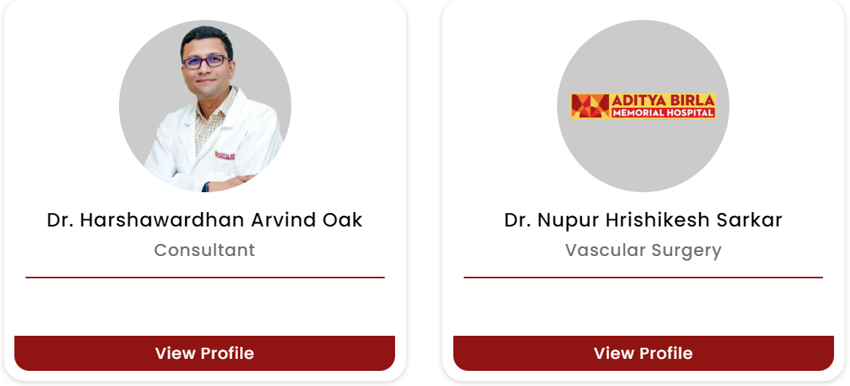
Our vascular care team is renowned for its expertise in treating a wide range of conditions. Whether you need treatment for varicose veins or a life-saving intervention, our vascular specialists in Pune deliver patient-focused care with cutting-edge technology, ensuring some of the best outcomes.
What Our Vascular Surgeons Specialise In:
- Diagnosis and treatment of peripheral artery disease (PAD)
- Varicose and spider vein treatments
- Aneurysm repair, including abdominal aortic aneurysm (AAA)
- Carotid artery surgery to prevent stroke
- Dialysis access creation and maintenance (AV fistula/graft)
- Deep vein thrombosis (DVT) and venous insufficiency management
- Minimally invasive endovascular procedures
- Bypass surgeries to restore blood flow
- Wound care for non-healing vascular ulcers
- Management of vascular trauma and emergencies

How to Find the Top Vascular Surgeons Near Me in Pune?
If you’re searching for the best vascular surgeon in Pune, our vascular surgery hospital in Pimpri Pune stands out for its blend of expertise and compassionate patient care. Each treatment is tailored to individual needs, ensuring optimal results every time.
Nearby Locations:
Hinjewadi, Wakad, Baner, Aundh, Pimple Saudagar, Bhosari, Chinchwad Gaon, Tathawade, Nigdi, PCMC, Pimpri, Ravet, Moshi, and Chakan


